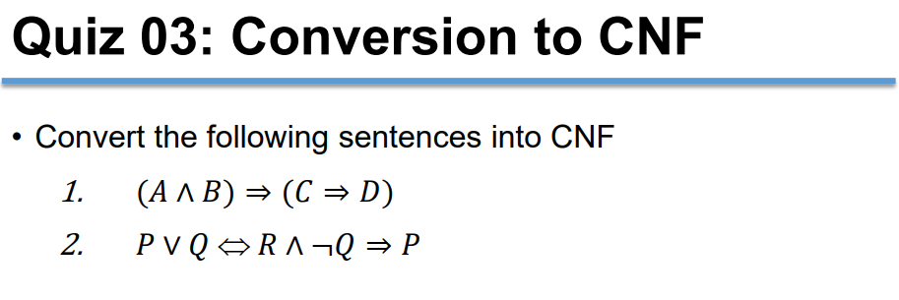

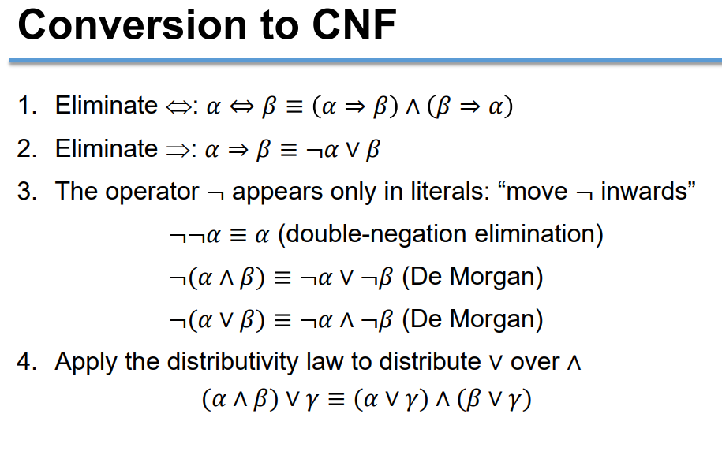

Conversion to CNF

1. (A and B) => (C and D)

|  |
| --- |
| -(A and B) or (C and D) |
| -A or -B or (C and D) |
| (C or -A or -B) and (D or -A or -B) |
| C or -A or -B  D or -A or -B |

(A and B) => (C and D)’s cnf form is (C or -A or B) and (D or -A or B)

1. P or Q or R and -Q => P

|  |
| --- |
| P or Q => (R and -Q => P) <1>  (R and -Q => P) => P or Q <2> |

<1> P or Q => (R and -Q => P)

|  |
| --- |
| -(P or Q) or –(R and -Q) or P |
| (-P and -Q) or -R or Q or P |
| -P or -R or Q or P will become -R or Q  -Q or -R or Q or P will become -R or P |
| -R or Q  -R or P |

<2>(R and -Q => P) => P or Q

|  |
| --- |
| -( -(R and -Q) or P) or P or Q |
| -( -R or Q or P) or P or Q |
| (R and -Q and -P) or P or Q |
| R or P or Q  -Q or P or Q will become P  -P or P or Q will become Q |
| R or P or Q  P  Q |

P or Q ó R and -Q => P ‘s cnf form is (-R or Q) and (-R or P) and (R or P or Q) and P and Q

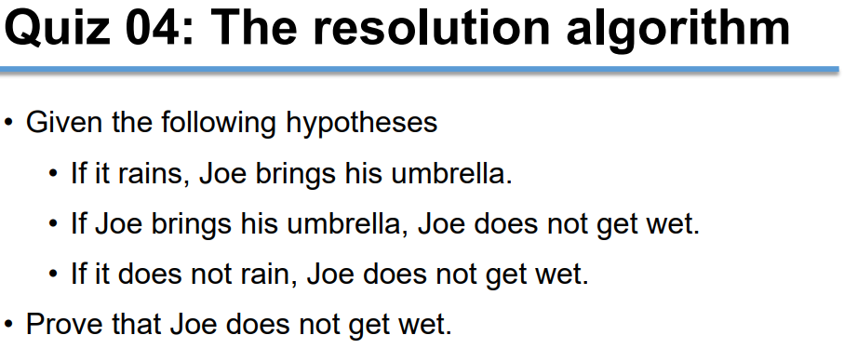

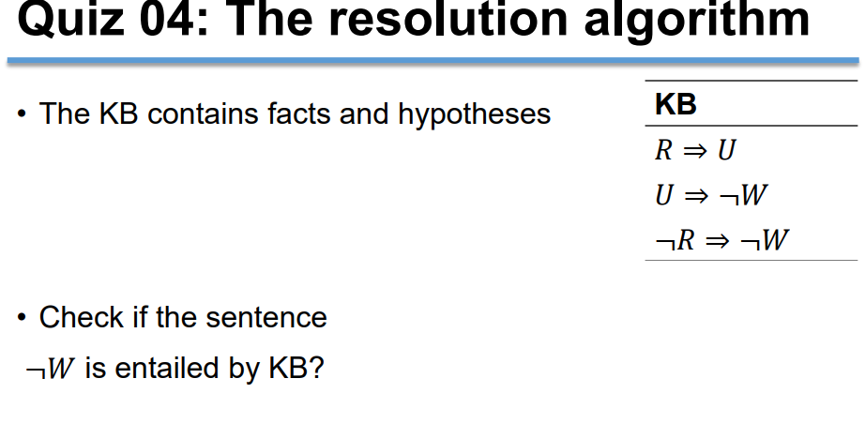

|  |  |
| --- | --- |
| 1. R => U | From KB |
| 1. U => -W | From KB |
| 1. -R => -W | From KB |
| 1. W | Negative of -W (alpha) |
| 1. R | (3), (4) |
| 1. U | (1), (5) |
| 1. -W | (6), (2) |
| 1. false (-W and W) | (7), (4) |

So, KB entails alpha

Review 06

Question 2

|  |  |
| --- | --- |
| (1)-P or R | KB |
| (2)S or P | KB |
| (3)-S | KB |
| (4)-R or Q | KB |
| (5)Q | Negative of -Q |
| (6) R or S | (1),(2) |
| (7) -P or Q | (1), (4) |
| (8)P | (2),(3) |
| (9)S or Q | (2), (7) |
| (10)R | (3),(6) |
| (11)Q | (3),(9) |

No more new clause ⇨ KB does not entails -Q

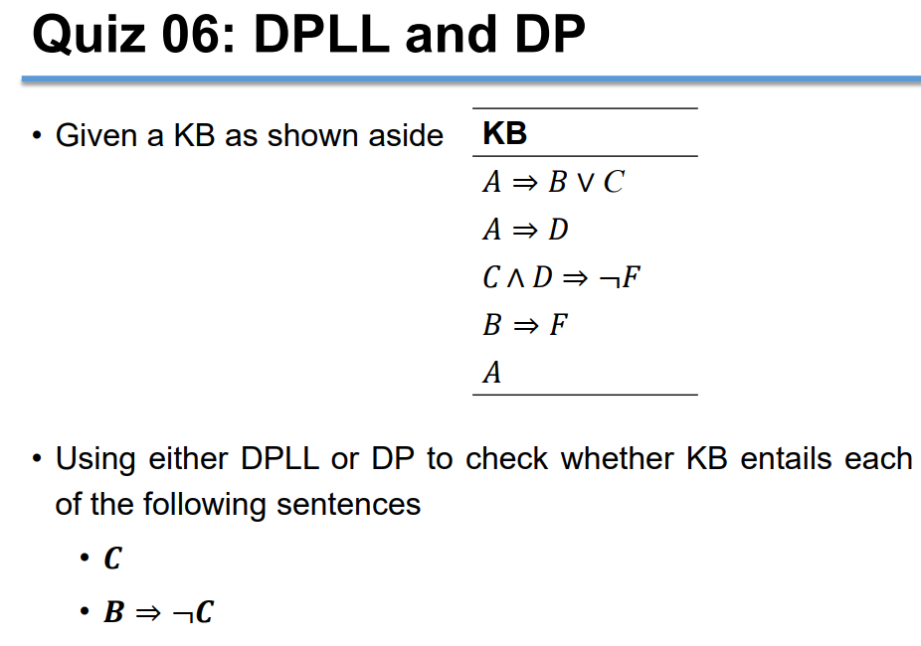

## Just In Case

